DAY – 14 (21.06.2024)

1. 1. Find the M-th maximum number and Nth minimum number in an array and then find the sum and difference of it.

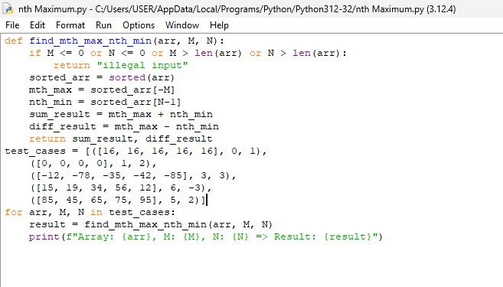

2.Consider a two integer arrays nums1 and nums2, sorted in non-increasing order and two integers m and n, representing the number of elements in nums1 and nums2 respectively. Write a program to Merge them into a single array using Merge Sort. Derive time complexity of merge sort

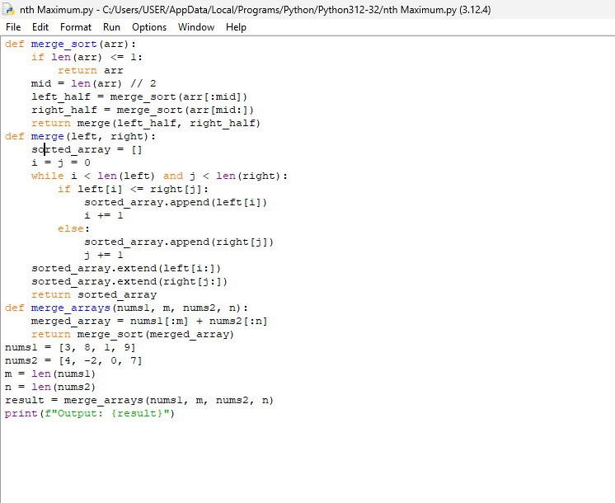

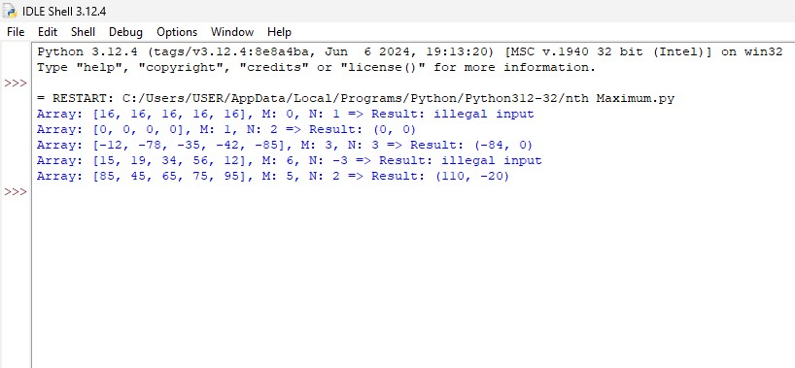

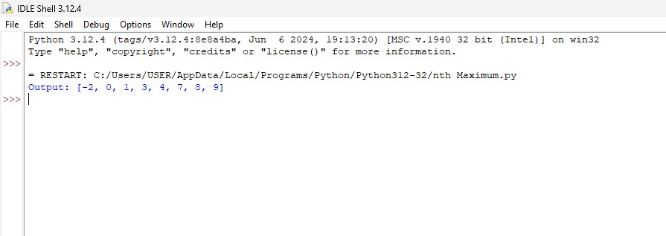

3.Write a program to find the sum of digits. You are given a **0-indexed** array nums consisting of **positive** integers.

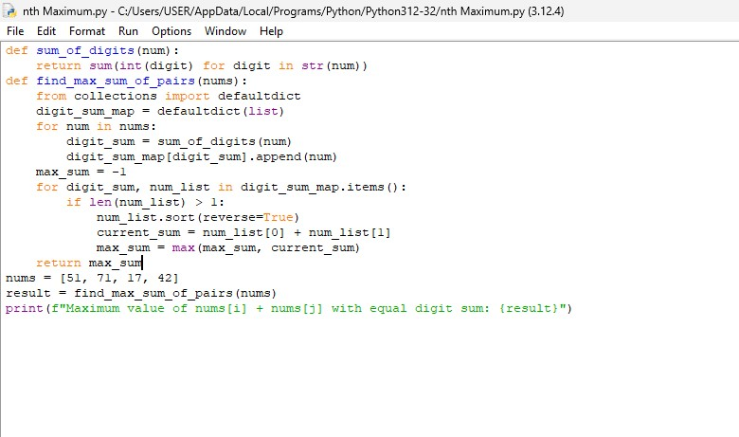

4. Write a program to find all pairs shortest path using Floyd's technique and to estimate its time complexity.

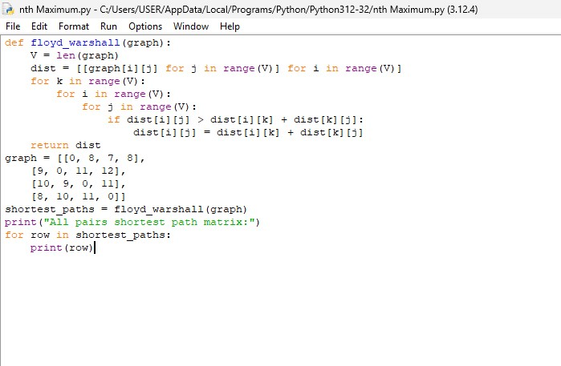

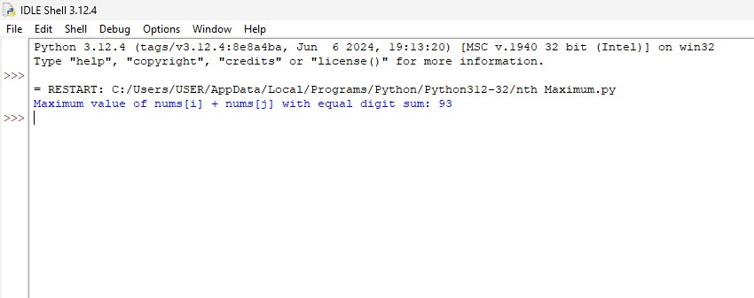

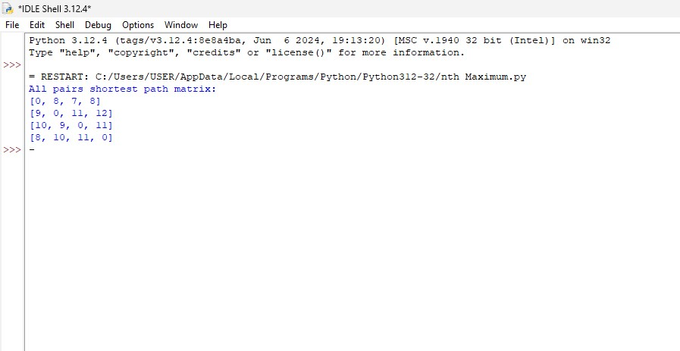

5. Write a program to perform linear search and estimate time complexity. Compute the amount of time for completion.

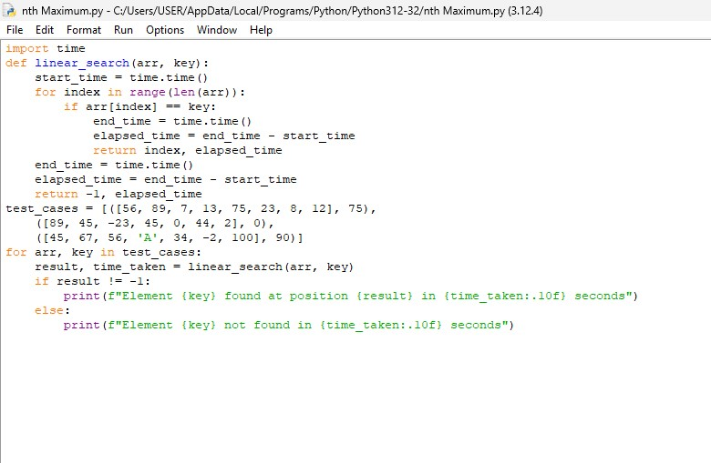

6. Write a program to compute Binomial coefficient for n=8, k=8 using dynamic programming

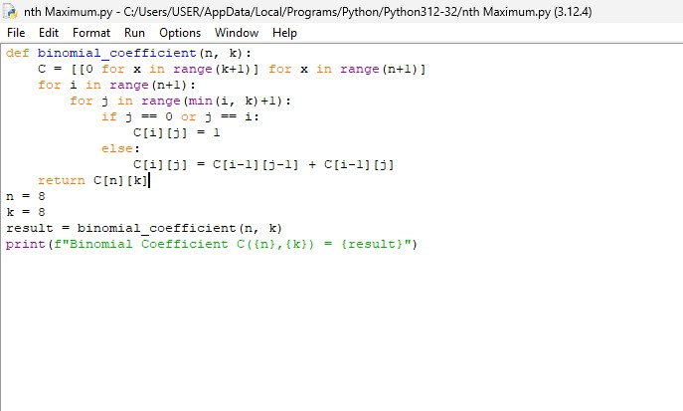

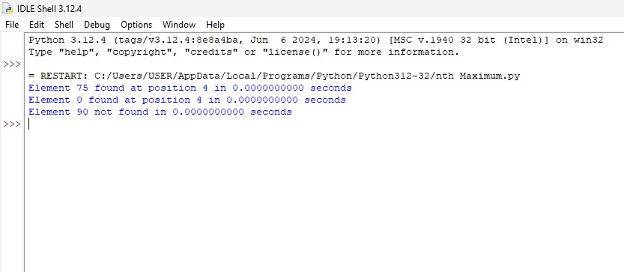

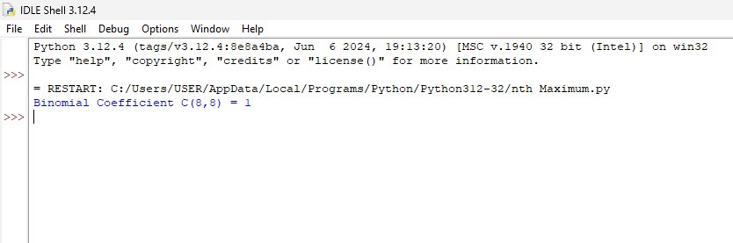

7. Write a program to find the factorial (fact)of a number and to estimate time complexity.

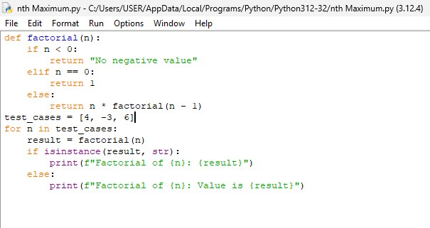

8. Write a program to perform Knapsack problem using greedy approach for the following set of object values.,

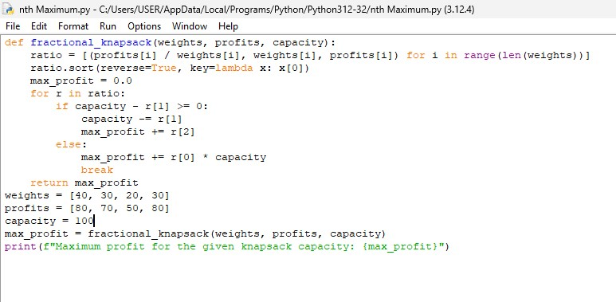

9. Write a [Program to find even Sum of Fibonacci Series Till number N](https://www.geeksforgeeks.org/java-program-to-find-sum-of-fibonacci-series-numbers-of-first-n-even-indexes/)?

